6. What is a Q-Q plot? Explain the use and importance of a Q-Q plot in linear regression?

Answer-->
Quantile-Quantile plot or Q-Q plot is a scatter point distribution between the data points and the quantile values.
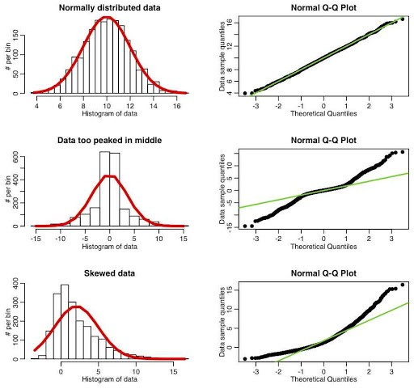

If the scatter points fits in a single line, we may assume our distribution assumption normal/uniform/skewed is correct.

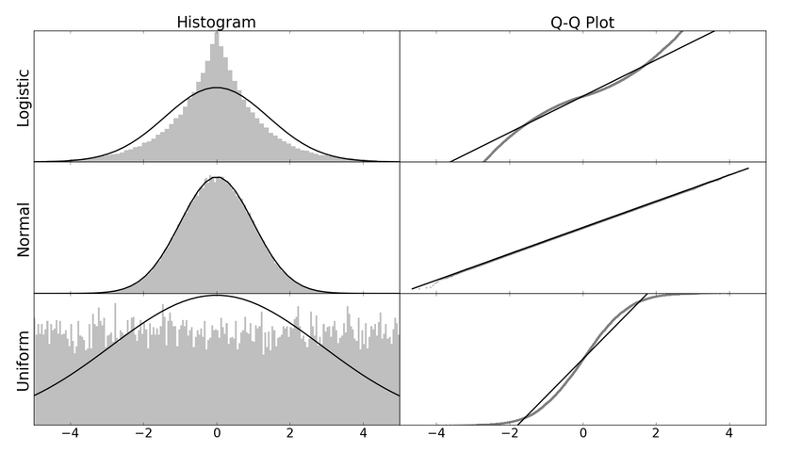
Steps:
1. plot the data on the chart.
2. assign quantile values to each data point.
3. assume a uniform/normal/skewed distribution.
a. uniform distribution – distance between each quantile value is constant.
b. normal distribution – points at the median position are closer to each other whereas points faraway fro mean/median are faraway from each other.
c. skewed distribution – points at one of the end are closer to each other whereas points at the other end are faraway from each other.
4. plot a scatter graph with data points and their quantile values. If all of these points lie on a line, the distribution assumed is correct, if wrong assume different distribution.

